Title: Eu Budget
Subject: EEP 11

1. EU Budget  A. Key info  B. Critics  E. Rationale  F. Struture  a. Multiannual Financial Framework  b. Annual EU Budget  I. Idea  II. Procedure  i. Proposal  ii. Adoption  iii. Execution  iv. Technical Control  v. Political clearing  G. Budgetary principles  H. Expenditures  a. Areas of expenditure  b. Evolution of expenditure  I. Revenues  K. Contributions and benefits: The net Balance  a. Who benefits more, who less?  b. Italy  b. You should not care that much  L. Critics  a. Equity  b. Autonomy and transparency  2. Next Generation Eu  A. Next Gen Vs MFF  B. Characteristics  a. Structure  b. Expenditure: the RRF | The EU budget is the tool through which money is collected and spent for EU policies. Very modest dimension: around 1.2% of EU GNI. Much less than nat gov’s budgets (ex. 55% GDP France). Small, but fundamental political importance, reflected in the legislative procedure needed for adoption. Intuition: a discussion on how much to spend, and in which areas, is a discussion about the develop (or not) of EU, on how big you want eu to be.  For the Eurosceptics:  - EU budget goes to fund concrete activities: cost of the EU Institutions (administr expen) about 7%  - the EU budget does not finance activities covered by national budgets (no unnecessary duplication)  - the EU budget is small: amounts to an expenditure of about 95 cents per EU citizen / day. Is the EU worth (less than) a coffee each day?  - There is a large correspondence between payers and beneficiaries: only 9% of the total expenditure goes to non-EU countries  Why do we need an EU budget?  ‘Double market failure’, i.e., when private mkt (first failure) and the national public one (second failure) => provide suboptimal amount  Ex 1: Transport  1st mkt failure (Private): some less populated routes would not be covered => national gov intervenes.  2nd mkt failure (Public): single countries would invest in a sub-optimal way (e.g. a tunnel between France and Italy benefits Spain as well by improving the single market but spain is free riding)  => Trans-European networks benefit all countries (positive externalities).  Ex 2: R&D  A. Multiannual Financial Framework (MFF). Art. 312 of the TFEU:  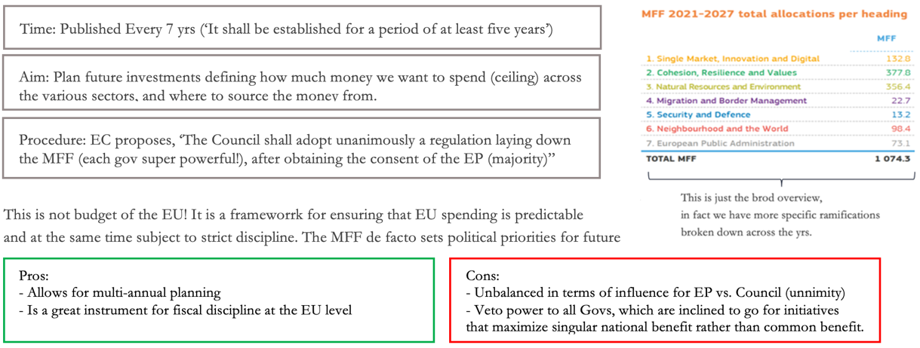  B. Annual EU Budget: Given the constraints set by the MFF, every year we approve a detailed annual EU Budget  a. Procedure  1) Proposal. The EC prepares the draft budget (DB), and submits it to the Council and EP in year t-1 (e.g. 2021)  *there is a huge apparatus that keeps the eu institution continuously in touch. Commission know the ideas of council and parliament, will try to mediate. Usually ministries tend to be more conservative (they re those who pay), European parliament to foster the growth of eu  2) Adoption  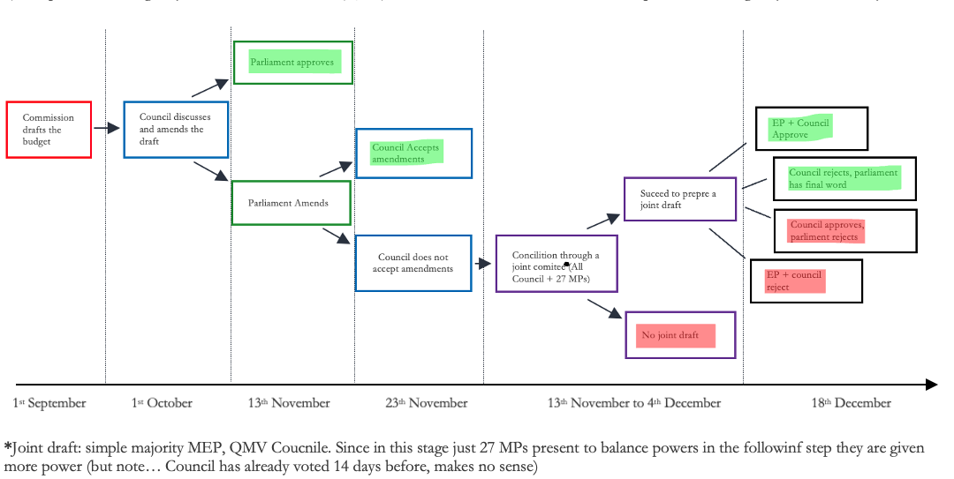  3) Execution: The EC is the main responsible for implementing the budget in year t (2022)  4) Control: The Eu Court of Auditors audits in year t+1 the EU accounts (2023, on the 2022 budget) and then issues a verdict  5) Policitcal clearing (Discarge): Discharge is the final approval (sets closure) of the EP on how the EC implemented the budget, by year t+2. Need qualified maority (50%+1) and, in case the political clearing is not given, it can cast, by overqualified majority (66%+1 of the EP members) a vote of non- confidence to dismiss the Commission. This has never happened... but we got pretty close to it!*  *In 1998 a whistle-blower working in the EC, had sent the EP a report: ‘officials received instructions to obstruct the audit examinations’. In a vote on 17 December 1998, the EP denied the discharge of the budget, then Commission President Santer announced the mass resignation of the EC.  Extra: If, at the beginning of a financial year, the budget has not yet been definitively adopted, a sum equivalent to no more than one twelfth of the budget appropriations for the preceding financial year may be spent each month (art. 315 TFEU). <= roll over busget of the previous yr  Unit of account: €  Annuality: we have one yearly budget within the multi-annual programming period =>  Multi-annual programmes are committed in the year they are decided, while paid over the years as implementation progresses  Universality  No earmarking = no use of a specific revenue to finance specific expenditure  Specification: every committed expenditure must have a specific scope and purpose = The budget is divided into sections titles…  Equilibrium: “The revenue and expenditure shown in the budget shall be in balance” => Any deficit or surplus should be corrected by member states’ contributions = Eu Budget is not an autonomous tool of fP (fiscal policy requires G > T, hence you need deficit(debt), but balance rule does not allow). Politically conscious choice of limiting the financial autonomy of the EU.  Unity  All expenditures and revenues must be found in one document (the budget).  Commitment appropriations: the expenditure committed by the EU in a given year wrt operations to be carried out across several years  Payment appropriations: the expenditure de facto incurred by the EU in a given year for the commitments of current yr.  Even though the EC is the main responsible for implementing the budget, in practice, some 76% of the budget is spent under 'shared management', with individual EU countries distributing funds and managing expenditure. EC defines plan then gives money.  5 main areas of expenditure (formal cathegories):  ADMINISTRATION  Natural resources and environment: agriculture, rural development, fisheries, environment and climate change ’  AGRICULTURE (CAP)  EXTERNAL POLICIES  INTERNAL POLICIES  money spent for other purposes (no agricultural or structural).  STRUCTURAL  Fostering convergence by supporting I in poorer regions  Migrant and border management, security and defence, neighbourhood and the world + neighbourhood and the World (pre-accession assistance to candidate members, European Neighbouring policies, humanitarian aid, development cooperation)  “Single Market, Innovation and Digital, research, student mobility (Erasmus), energy, competivness trans-European transport networks”  ‘Cohesion, Resilience and Values’  Evolution of expenditure  Increase of expenditure (overall steady growth in budget over time) but always below 1.2% of eu GNI  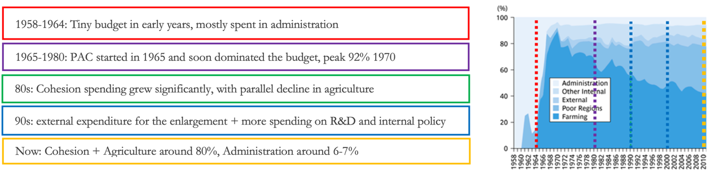  Revenues  Revenues  4. Plastic own resource  • National contribution based on the amount of non-recycled plastic packaging waste (€0.80 per kg). Less wealthy States: They get back €0.80 paid on a number of kg equal to 3.8 population. That is, no contribution for up to 3.8 kg/citizen. Smart: It is a resource, but it is also an incentive for states to reduce pollution. Good Direction!  3. GNI  • Introduced as a marginal resource in the 1980s: contributions from MS to make eq in the budget hold. Financing: The rate is fixed during the budgetary procedure (now 0.7-0.8%). The same % on each State’s GNI. A reduction has been granted to: Den, Ger, Net, Swe, and Aut. The transfer is national gov def!  2. VAT  • Tax on Consumption. It is computed by applying a Eu VAT rate (today 0.3%) to a VAT base*  *tax revenue = tax rate $×$ tax base  => tax base = tax Rev / tax rate  Note: there is a cap st if VAT base > 50% of GNI you use 50% GNI. Why cap? VAT is regressive. Poorer countries will have a tax base reltively high wrt total GNI.  1. “Traditional” own resource (Tor)  • Custom duties collected by nat customs authorities and transferred directly to the EU coffers (States keep 25%). Until 2017 there were also sugar levies. this is the first and most complete expression of the financial autonomy of the EU (automatic)  Dimension:  • Very small and (hopefully?) transitory  • From 10% in 1988 to 73% now. Now resources for the EU are largely in the hands of the EU govs = loss of financial autonomy for the EU. EP is ambitious but gov do not want to expand deficits  • The VAT own resource makes up around 12% of total revenues.  • In the 1970s and 1980s, 50% of the EU revenues; Now 15%. Their decrease is due to:  (1) the increase in the absolute size of the EU budget;  (2) the reduction of the EU tariff revenues due to  i. The enlargements  ii. WTO  iii. Creation of FTAs  E. Other resources (around 1% of total): tax on EU staff remuneration, fines paid by companies violating competition rules, bank interests etc.  Expanding Eu own resources:  New own resource based on taxes on π of large MNEs. EC has proposed to send 15% of reallocated profits to EU budget. Plus 0.5% of the national EU company profit base, an indicator calculated by Eurostat on the basis of the national accounts statistics  ETS: EU Commission has proposed to send 30% of generated revenues to EU budget.  CBAM. That is, a tariff on goods produced in countries with less stringent environmental regulation. EU Commission has proposed to send 75% of generated revenues to EU budget.  Non-recycled plastic packaging waste based contribution  + Working on introducing other new own resources, possibly a financial transaction tax  Inflows: Relatively poorer countries receive relatively more payments (as a % of GDP). This is a natural outcome of EU policies (ex. cohesion)  Outflows: No progressivity in contributions (contributions /GDP $≈$ 1%)  => Overall balance is sees a surplus for small east countries, a deficit for west ones.  Italy:  - Italy has always been a net contributor to the EU budget + Italy has never been bailed out + Italy has always contributed to bail out others  - Yet... the perception of many external observers is that Italy has been kept alive by, say, German taxpayers  => That is simply not true. It is only with Next Generation EU, as we will see later, that Italy becomes a net beneficiary.  Does it actually make sense to think at net balances?  Net balances are not a policy objective per se, but a simple outcome of policies. Eu is not about a zero sum accounting game where the gain of one player comes at the expense of another. Accounting games gives no info ‘relating to the internal market and economic integration, not to mention political stability and security’ => The focus on net-balances reflects a narrow inter-governmental, non-solidaristic vision of Europe + Economically misses a huge part  Moreover: EU budget is small = peanuts, very low price for sustaining a large single market, and financing infrastructural investment in relatively poorer countries that end up benefiting also companies in richer countries.  - The corrections negotiated on the revenue side (GNI) partially undo the impact of certain expenditure policies.  - The VAT resource has a regressive impact (poorer countries tend to bear a relatively large share), not entirely solved by the 50% capping (benefiting some of the richest countries like Lux or Irl)  - Keeping 25% of custom duties as collection fee is arguably too much  - The financing system is opaque and complex (what can citizen undertand…)  - GNI perceived as national contrinutions  - Contributions represent an expenditure item in national budgets (prisoner of Eu budget). EC aks discipline but at the same time needs money.  C. Next Generation Eu  Next Generation EU comes on top of a ‘standard’ MFF 2021-2027, as a countermeasure to the COVID-19 crisis. Even though part of the funds are spent through the MFF categories, they are legally distinguished from the MFF (i.e., exception to the equilibrium principle).  Financing and Expenditure  The EU Commission is allowed to borrow on the market 750 bn:  Up to 360 bn can be used to provide “loans”  Up to 390 bn can be used to provide “grants” (either through standard MFF programs, or through RRF...)  Allocation across countries based on: population, GDP per capita,  unemployment, impact of COVID-19. To clarify: if Ger gets a “loan”  from the EU Commission, this amount contributes to Ger public debt  and has to be repaid by Ger .Grants instead are repaied by Eu EU.  Since Germany contributes to the own resources of the EC, part of the  received grant is actually also repaid by Germany itself. The net amount  of money received is lower than the grant if you are a net contributor to  the MFF  Recovery and Resilience Facility (RRF) centerpiece of NGEU <= mainly enters the cohesion resilience and values cathegory in the MFF.  This accounts for 360bn of loans and 312.5 of grants. Countries need to prepare national recovery and resilience plans for 2021-2023 (PNRR in Italy). These need to be consistent with the country-specific recommendations and contribute to green and digital transitions . Disbursements approved by Council with QMV, upon reaching targets  Funds have to be borrowed and spent by 2026 (70% of funds to be used in 2021-2022, not achieved!)  At least 37% in climate-related projects, 20% in digital transformation  According to Commission’s guidelines, money should be spent in:  - Power up, Recharge and Refuel  - Renovate (private buildings)  - Modernise (digitalisdigation of public adm/ judicial/ healthcare), Connect (5G), Scale-up (cloud)  - Reskill and upskill (education, vocational training)

